Task 01:

Builder

package com.BuilderMethodDP;

public class BuilderDPDriver {
public static void main(String[] args) {
GadgetBuilder builder = new MobileGadgetBuilder();
GadgetDirector director = new GadgetDirector(builder);

Mobile mobile = director.constructGadget();

System.out.println("Mobile Configuration: " + mobile);
}
}

Task 02:

Adaptor

// Assuming this is the adapter class
public class Iphone16Adapter implements Iphone {
private Charger charger; // The adaptee

public Iphone16Adapter() {
this.charger = new Charger();
}

@Override
public void onCharge() {
charger.charge();
// The output "I am charging Iphone 16" and "Stopped charging Iphone 16"
// indicates these methods are probably within Charger.
}

@Override
public void offCharge() {
charger.removeCharge();
}
}

Task03:

Create a class diagram in uml.

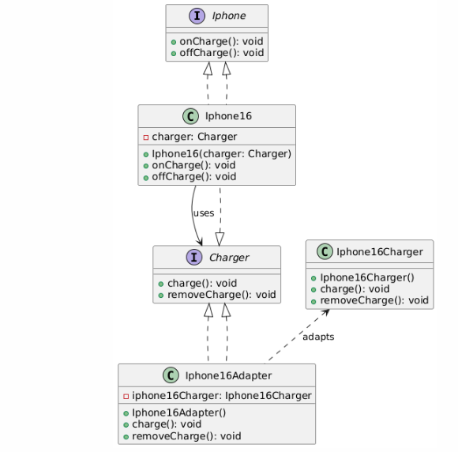

Task 04: Commonly Used Visibility Notations in Class Diagrams
In UML class diagrams, visibility notations define the accessibility of a class member (attribute or operation). Here are the most common ones:
- + (Public): Accessible from anywhere.
- - (Private): Accessible only within the class.
- # (Protected): Accessible within the class and its subclasses.
- ~ (Package): Accessible to classes within the same package.

Task 05: Parameter Directionality
Parameter directionality in UML specifies the flow of data for an operation's parameters. They are:
- in: The parameter is an input; data flows into the operation. This is the default.
- out: The parameter is an output; data is passed back to the caller.
- inout: The parameter is both an input and output; data is passed in, modified, and returned.
- return: The return value of the operation.

Task 06: Class Relationships
UML diagrams use various relationships to show how classes interact.
- Association: A general link between two independent classes, where one class knows about or uses the other. For example, a student is associated with a teacher.
- Aggregation: A "part-of" relationship where the parts can exist independently of the whole. This is a weak "has-a" relationship, represented by a hollow diamond. For example, a Department has Professors; if the department closes, the professors still exist.
- Composition: A strong "part-of" relationship where the parts cannot exist without the whole. This is a strong "has-a" relationship, represented by a filled diamond. For example, a House contains Rooms; if the house is destroyed, the rooms are too.
- Inheritance: An "is-a" relationship where a subclass inherits properties and behaviors from a superclass. This represents a hierarchical structure. For example, a Dog is an Animal.

Task 07:

Package notation

Answer:

Package Notation is used in UML (Unified Modeling Language) to group related classes, interfaces, diagrams, or other UML elements under a common namespace. It's a way to organize large systems into manageable parts.

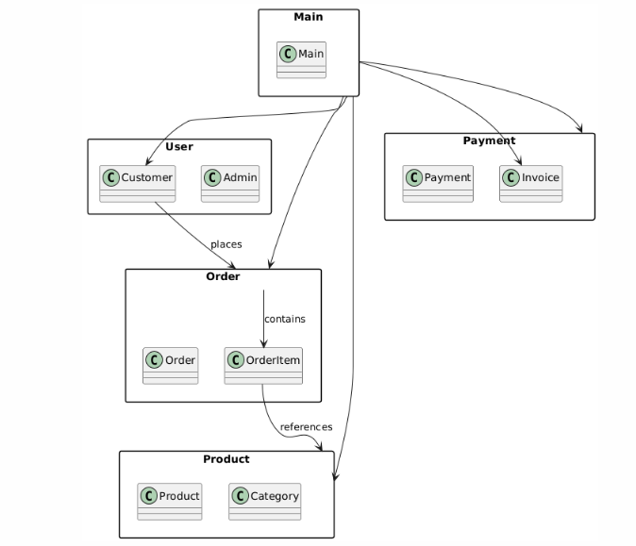

Task 08

State Notations in UML
State notation is used in UML State Machine Diagrams to represent the different conditions or modes an object can be in.
- Initial State (●): Represented by a solid black circle, this is the starting point of the state machine. An object begins its lifecycle in this state.
- Final State (◎): Represented by a black filled circle surrounded by a white ring, this indicates the end of a state machine's lifecycle. An object that reaches this state has completed its activity.

